PRESS RELEASE

Ostend-Bruges Airport announces satisfactory year results 2017
Ostend, 5th January 2018 – During the year 2017 Ostend-Bruges Airport welcomed 365.345 passengers, registered 22.708 flight movements and treated 23.369 tonnes of cargo.
Results
Although 365.345 passengers in 2017 represent a decrease of 16% compared to 2016, the overall result is remarkable. Following last year’s Terrorist Attacks in Brussels, the airport welcomed 120.000 extra passengers unable to fly from Brussels Zaventem. When excluding these passengers from the total result, Ostend-Bruges Airport would achieve in 2017 an increase of 15% compared to 2016.
The airport increased its cargo trafic with 5% compared to 2016, with the strongest growth during the last 3 months of the year.
Future
This upcoming summer season the airport offers four new destinations with TUI adding flights to Sharm el Sheikh, Hurghada, Corfu and Djerba. TUI will now operate a total of 25 summer routes from Ostend-Bruges Airport.
Interest for cargo flights also increases since freight forwarders are in search of alternatives for the much congested airports of Amsterdam, Liège and Brussels.

General Aviation is expected to grow due to the construction of the Business Terminal. Private- and business flights will provide a new boost to Ostend-Bruges Airport starting with the official opening of the Business Terminal next year.
Marcel Buelens, CEO of Ostend-Bruges and Antwerp Airport said: “both commercial- and cargo flights follow a well defined trend at Ostend-Bruges Airport. Passengers prefer the advantages of flying from their regional airport in Flanders, and cargo carriers show significantly more interest due to our capacity and possibilities for future development.”

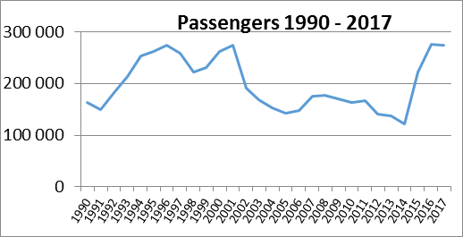

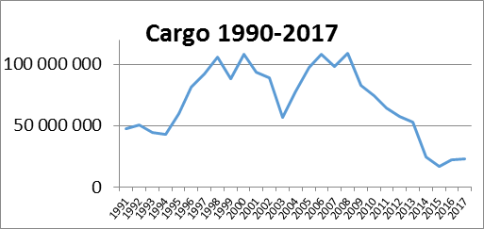

Stats
 | 2016 | 2017 | difference %
passengers | 434 970 | 365 345 | -16%
Passengers * | 318 301 | 365 345 | +15%
cargo | 22 224 | 23 369 | +5%
movements | 24 183 | 22 708 | -6%
Passengers *: this amount reflects the number of passengers excluding the additional passengers following the terrorist attacks of March 2016.
Best month August: 54.390 passengers
Most popular destination Alicante
Total number of staff 109
Number of airlines 1
Number of cargo carriers 2
Number of routes 25

About Ostend-Bruges Flanders International Airport
The international airport of Ostend-Bruges is part of the french group Egis, which commercially manages the airport while the regional authorities remain in charge of the basic infrastructure. An important part of the airport activities focusses on cargo flights. Besides freight transport, the airport offers scheduled flights, operated by TUI. The airport caters also for private plains, business flights, training- and ad hoc flights.
In 2017 the international airport of Ostend-Bruges welcomed 365.345 passengers, 22.708 flight movements and 23.369 tonnes of cargo were processed.
www.ostendairport.aero
Press contact for Ostend-Bruges Airport
Catherine Stuyck – catherine.stuyck@ostendairport.aero

